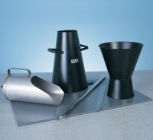 | 300 mm Stainless Steel Rule.  Code: 34-0140  Product Group: Slump Test

Further Information
**NOT AVAILABLE FOR SALE IN THE USA**

