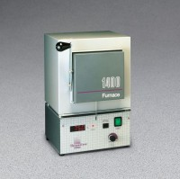 | Standard Muffle Furnace  Code: 88-0110/02  Product Group: Standard Muffle Furnace  ELECTRICAL RATINGS:  Model  Volts  Amps  Watts  Phase  Frequency  FB1315M  120  8.8  1050  1  50/60  TEMPERATURE:  Operating range (continuous): 982°C; (intermittent): 1100°C  ENVIRONMENTAL CONDITIONS:  Operating: 17°C - 27°C; 20% - 80% relative humidity, non-condensing. Installation Category II (over-voltage) in accordance with IEC 664. Pollution Degree 2 in accordance with IEC 664. Altitude limit: 2,000 meters.  Storage: -25°C - 65°C; 20% - 80% relative humidity.

Specification
Temperature Range | 982°C - 1100°C
Heating Time | To 871°C (1,600°F) in approximately 40 minutes.
Input Control | Selects from 5 to 100% of full rated input.
Heating Elements | Embedded on three sides.
Door | Swing-down type with safety switch.
Inner Dimensions | 4” w. x 4.5” d. x 3.75” h. (10 x 11 x 9.5 mm).
Overall Dimensions | 7.9” w. x 8.5” d. x 13.2” h. (254 x 279 x 368 mm).
Weight | Net 15.4 lbs. (7 kg); Shpg. 26 lbs. (12 kg).

