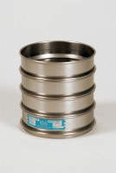 | 8in Dia ASTM Sieve 3.35mm Stainless Steel Mesh.  Code: 79-5040  Product Group: U.S Standard Testing Sieves, 8" Diameter ASTM Sieves, 8" Diameter ASTM Sieves, 8" Diameter ASTM Sieves

Standards
ASTM E11

Specification
Frames | Full height; 2â (51 mm) depth  to mesh.
Construction | Polished and lacquered brass with S.S. mesh.
Nameplates | Show standard, alternate and Tyler Screen Scale equivalent designations.
Weights | Net 1 lb. (453 g).
Sieve Size or Number | No. 6
Sieve Opening Standard | 3.35 mm
Sieve Opening Alternative (in.) | 0.132

