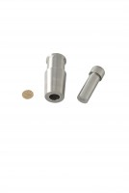 | Blaine Air Permeability Cell  Code: 38-1000/15  Product Group: Blaine Fineness Apparatus, Determination of Fineness Blaine Apparatus  Spare: Stainless steel with a perforated disc and plunger.

Standards
ASTM C204

