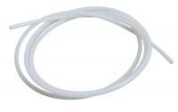 | Nylon Tubing 6mm Od 3500Kpa.  Code: 26-1926  Product Group: Volume Change Measurement, Permeability of Rock  6 mm outside diameter x 4 mm inside diameter. For use up to a pressure of 3500 kPa. Priced per metre.

