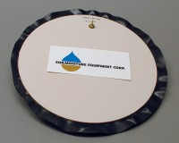 | 15-Bar Pressure Plate Cell.  Code: 532-120/10  Product Group: Pressure plate extractors

