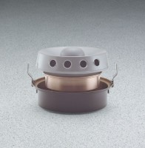 | Master Humidifier  Code: 34-6775/02  Product Group: Master Humidifier

Further Information
110-120vAC, 60 Hz, 1ø. 90 Watts.

Specification
Evaporation Rate | 1/2 gal./hr.; incomplete evaporation after  95% humidity.
Output | 5 lbs. vapor/hr. (2 kg/hr.); up to 6 ft. (2 m) horizontally.
Coverage | 2,000 ft3 room with moderately insulated,  non-absorbent walls, and without appreciable air exchange.
Motor | Sealed, ball-bearing type.
Water Reservoir | Heavy gage copper; lacquer finish.
Water Valve Float | Heavy gage copper; lacquer finish.
Water Supply | Cold; connects through 1/8â (3.2 mm) male  pipe thread.
Operating Water Pressure | 10-100 psig (0.7-7.03 kg/cm2).
Dimensions | 14 -1/4â (369 mm) diam. x 10-1/2â (267 mm) h.
Weight | Net 19 lbs. (8.6 kg).

