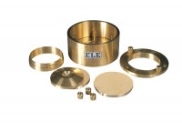 | Cutting Ring for 25-0479  Code: 25-0482  Product Group: ASTM/AASHTO consolidation cells and accessories, Fixed Ring Consolidation

Standards
ASTM D2435, ASTM D4546, AASHTO T216

