 | Dial Indicator Holder  Code: 88-4194  Product Group: CBR-Test 50 Machine

Spares/Consumables
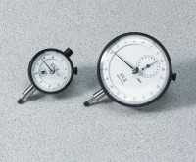 | Dial Indicator - 1.0" Range  Code: 88-4100

