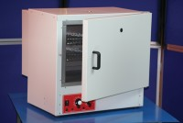 | 50 Litre Drying Oven  Code: 78-1215/01  Product Group: Oven Drying Method, Oven Drying Method, Oven Drying Method

Standards
BS 2648, BS 598, BS 1377, BS 1924

Further Information
**NOT AVAILABLE FOR SALE IN THE USA**

