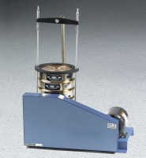 | Sieve Shaker - Motorized 220V 60 Hz  Code: 80-0445/06  Product Group: Laboratory Sieve Shakers  220vAC, 60 Hz, 1ø.

Specification
Capacity | 7 sieves, 8â (203 mm) diam., plus pan and cover.
Guard | Steel construction; supplied as standard on motorized versions.
Motor | 1/4 h.p.; belt driven.
Dimensions | 23 â w. x 13 â d. x 33 â h. (584 x 330 x 838 mm).
Weight | Net 63 lbs. (28.6 kg).

