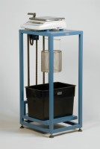 | Buoyancy Balance 6Kg X 0.1G. Supplied with Support Frame Water Tank & Suspension Hook.  Code: 42-1000/01  Product Group: Particle Density (specific gravity) and Water Absorption for Coarse Aggregates  The buoyancy balance system developed by ELE consists of a rigid support frame, incorporating a water tank mounted on a platform. A mechanical lifting device is used to raise the water tank through the frame height immersing the specimen suspended below the balance. The balance supplied may also be used as a standard weighing device, thus providing a versatile and comprehensive weighing system in the laboratory.6000 g x 0.1 g supplied with frame, water tank and suspension hook.

Standards
EN 1097-6, EN 12697-6, BS 812, ASTM C127, AASHTO T85

Further Information
**NOT AVAILABLE FOR SALE IN THE USA**
For 220 - 240 V AC, 50 - 60 Hz, 1 ph.

