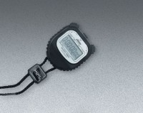 | Digital Stopwatch  Code: 88-4340  Product Group: Digital Stopwatch, Bitumen Penetration Test

Specification
Operation | Start-stop and lap split-reset push-buttons.
Time Range | Display up to 9 hours, 59 minutes, 59.99 seconds in 0.01 second increments.
Weight | 4 oz. (227 g).

