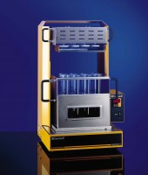 | Digestion Unit 8 place, semi-auto c/w block,rack, heat shield, exhaust,  Code: 525-355/01  Product Group: Kjedahl apparatus  Supplied with digestion block, carrying rack with heat shield, exhaust system, two-tier console, instruction manual and 8 digestion tubes, 250 ml, 300 x 42 mm.

Further Information
For 220-240 V, 50/60 Hz, 1 ph.

Spares/Consumables
 | Digestion Tube Macro 250Ml  Code: 525-355/10

