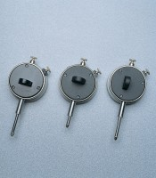 | Dial Gauge  Code: 83-5416  Product Group: Dial Gauges

Specification
Diameter mm | 57
Travel mm | 25
Grad. Mm | 0.01
Scale | RH
Anvil | Ball
Back type | C

