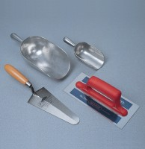 | Float - Plasterer’s type  Code: 81-0340  Product Group: Trowels and Floats

Further Information
**NOT AVAILABLE FOR SALE IN THE USA**

