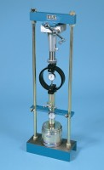 | Conversion Frame.  Code: 24-9341  Product Group: Conversion of In-situ to Laboratory CBR

