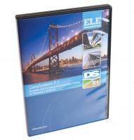 | DS7.1 Direct and Residual Shear Strength Program for Windows 7, 32/64 bit  Code: 27-1792  Product Group: Automatic Data Acquisition  This unique package provides test options for quick undrained or drained shear tests with the user selectable option of residual testing. Individual test results can be linked together to produce the Coulomb Envelope. Printouts and plots are available for sample description and basic test data such as moisture content, etc. Realtime  plots of settlement, shear versus displacement and vertical displacement during shearing is readily available via the PC screen or printer.

