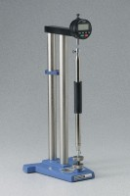 | Digital Length Comparator  Code: 34-8507  Product Group: Length Comparator  English or Metric units selectable.

Standards
ASTM C151, ASTM C157, ASTM C227, ASTM C490, ASTM C531, AASHTO T107, AASHTO T160

Specification
Frame | Metal, double-post construction; rust resistant finish.
Anvils | One movable and one stationary; shaped to receive contact points in sample bars.
Indicator | Digital indicator with English or Metric units selectable.
Reference Bar | Invar metal.
Dimensions | 7-1/2" w. x 7-3/4" d. x 17-3/4" h. (190 x 197 x 451 mm)
Weight | 14.9 lbs. (6.8 kg)

