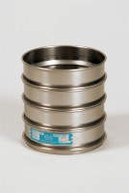 | 300mm Dia Receiver.  Code: 79-2020  Product Group: Sieve Lids and Receivers ISO and BS, 300mm Diameter BS Sieves, 300mm Diameter BS Sieves, 300mm Diameter BS Sieves

Standards
BS 410, ISO 3310

Further Information
**NOT AVAILABLE FOR SALE IN THE USA**

