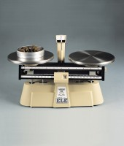 | Harvard Trip Balance  Code: 78-7090  Product Group: Mechanical Balances, Harvard Mechanical Trip Balance

Further Information
**Not available for sale in the USA**

Specification
Capacity | 2000 g
Resolution | 0.1 g
Pan size (diameter) | 2 x 150 mm
Overall dimensions (l x w x h) | 152 x 356 x 254 mm
Weight | 2.7 kg

Spares/Consumables
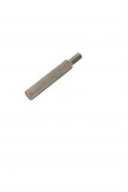 | Consistency Plunger  Code: 38-2010/10

