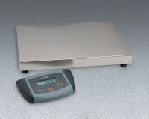 | ES Series Low Profile Bench Scale 220 lb Capacity  Code: 88-1428/02  Product Group: ES Series Low Profile Bench Scales  220 lb./100 kg. capacity. 120vAC, 50/60 Hz.

Further Information
120V, 50/60 Hz.

Specification
Capacity | 22 0 lb. x 0.1 lb.  or 100 kg x 0.05 kg.
Platform Size | 20.5â x 15 .7â (52 x 40 cm).
Power | 10 vDC/AC adapter (included) or six âAAâ  batteries (not included).
Weights | Net 33 lbs. (15 kg).

