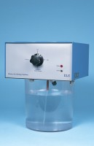 | De-Aired Water Apparatus. 15 L Cap. 220-240V 50/60Hz 1Ph.  Code: 25-1833/01  Product Group: N/A  This compact, self-contained unit will de-air water quickly and efficiently down to levels of dissolved oxygen acceptable for geotechnical test methods. Air is removed from the water by a vacuum system, which continuously circulates the water in the tank.  The unit is supplied with a clear water container, which will hold a maximum of 15 litres of water. Input and output lines are formed using standard 6 mm tube connectors.

Standards
BS 1377

Further Information
220-240V Ac 50/60Hz 1Ph

