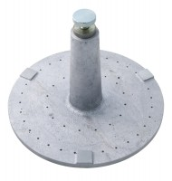 | Swell Plate  Code: 24-9260  Product Group: Expansion (swell) Test Equipment, Swell Plate  With adjustable stem.

Standards
ASTM D1883, AASHTO T193

Specification
Base Plate | 5-7/8” diam. (14 9.2 mm); perforated.
Contact Head | Adjustable; locks on stem with knurled nut.
Construction | All brass.
Weight | Net 2-1/2 lbs. (1.1 kg).

