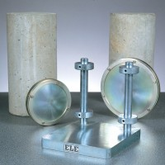 | Cylinder Capping Frame Complete with 100mm and 150mm Dia Capping Plates.  Code: 34-6031  Product Group: Sulphur Compound Method  Comprising of a vertical support, mounted on a steel base designed to accommodate both sizes of capping plates. Supplied complete with 100 mm and 150 mm capping plates.

Further Information
**NOT AVAILABLE FOR SALE IN THE USA**

