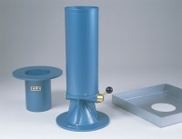 | 200mm Sand Pouring Cylinder.  Code: 29-4200  Product Group: Sand Replacement

Standards
BS 1377, BS 1924

