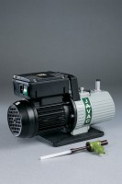 | Vacuum Pump  Code: 82-7720/01  Product Group: Vacuum Pumps

Further Information
**NOT AVAILABLE FOR SALE IN THE USA**

Specification
Type | Single stage
Pump | Oil filled rotary
Ultimate vacuum | 4 x 10-2 mbar
Displacement | 42 litres per minute (2.4 m³/hour)
Electrical supply | 220 – 240 V AC, 50 - 60 Hz, 1 ph
Weight | 12.7 kg

