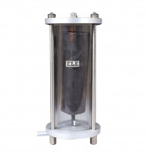 | Bladder-Type Air/Water Pressure Assembly. 1000 Kpa Maximum Working Pressure.  Code: 26-1746  Product Group: Air/Water Pressure Systems - up to 1000 kPa  With transparent plastic chamber for operating continuously at pressures up to 1000 kPa. A length of tubing is provided for connecting the air/water cylinder outlet to a pressure measuring system.  • Used to supply hydraulic pressure from a pneumatic pressure source.  • Prevents air entering the hydraulic pressure system.  • Maximum working pressure 1000kpa.  • Supplied with connectors and tubing for fitting to pressure measuring systems.

Spares/Consumables
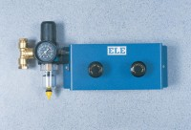 | Pneumatic Pressure Reducing Panel. Provides Two Independent Pressure Outlets 1000 Kpa Max.  Code: 26-1760
 | Replacement Bladder Wide Neck (38mm Id)  Code: 26-1746/10

