 | Electronic Digital Indicator, 0.600"/15 mm range  Code: 88-4210  Product Group: Electronic Digital Indicator, Direct/Residual Shear Apparatus, Table Top Consolidation Apparatus, Pneumatic Consolidation Apparatus  Resolution of 0.0001" (0.002 mm)

Spares/Consumables
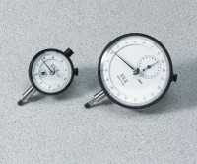 | Dial Indicator - 1.0" Range  Code: 88-4100
Electronic Digital Indicator, 0.250"/6.35 mm range
Code: 88-4200

