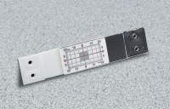 | Calibrated Crack Monitor  Code: 35-2510  Product Group: Calibrated Crack Monitor  Includes crack progress chart.

Specification
Construction | 10 Hz to 100 kHz in 4 switched ranges.
Discrimination | 0.5 mm.
Max. Crack Width Movement | 3/4â (20 mm); longitudinal.
Max. Upward Movement | 3/8â (10 mm); transverse.
Coeff. Of Thermal Expansion | 3.80 x 10-5 in/in/Â°F. (6.84 x 10-5 mm/mm/Â°C).
Dimensions | Grid: 1-1/2â x 3/4â (40 x 20 mm).  Plates: 1-1/4â x 4â x 1/4â (32 x 102 x 6.3 mm) ea.  Overall: 1-1/4â x 5-3/4â x 1/4â (32 x 14 6 x 6.3 mm).
Weight | Net 2 oz. (57 g).

