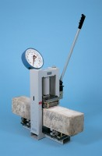 | 50 kN Mini-Flexural Machine  Code: 37-6040  Product Group: Hand-operated Flexural Machine  • Hand operated  • Rugged, high strength frame  • Double-action hydraulic pump  • Dual calibrated (kN/lbf) gauge  This compact flexural machine is designed for testing 100 mm and 150 mm square section beams. The base incorporates a series of bearer locating points, enabling a wide range of tests to be performed.  The unit is self contained with hydraulic pressure applied through a double-action hand pump to a ram fitted in the top of the frame making this an ideal portable onsite quality control machine. A 200 mm diameter load gauge, dual calibrated to 50 kN x 0.1 kN and 11000 lbf x 50 lbf graduations is fitted as standard.

Further Information
**Not available for sale in the USA**

