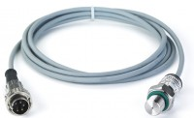 | Pressure transducer, 0-700bar, 0.05 to 10v DC Output  Code: 6014A0062  Product Group: Spares

Further Information
**Not available for sale in the USA**

