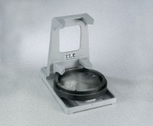 | 4" Cylinder Capper  Code: 34-6095  Product Group: 4" Cylinder Capper

Standards
ASTM C617, AASHTO T231

Specification
Frame | Two-piece cast aluminum construction;  adapts to optional capping plates.
Capping Plate | Two-piece construction; for 4â (102 mm)  diam. specimens.
Overall Dimensions | 6â w. x 8â d. x 7â h. (152 x 203 x 178 mm).
Weight | Net 10 lbs. (4.5 kg).

