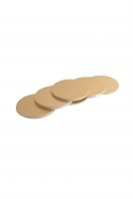 | Paper Discs  Code: 45-6462  Product Group: Accessories for manual and automatic compaction, Filter Paper Discs  Non-absorbent, 99 mm diameter, pack of 100.

Standards
EN 12697-30

Specification
Weight | Net 2.9 oz. (82 g).

