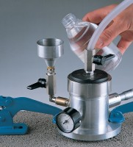 | Gwt Permeability Kit 0-6 Bar Range Supplied In A Carrying Case.  Code: 35-4043  Product Group: Permeability of Concrete  The Water Permeability Test Kit is a portable unit capable of measuring in-situ permeability. It has a dual measuring range of 0 - 1.5 bar or 0 - 6 bar. Consisting of a sealed water reservoir and all necessary attachments, the unit is supplied complete in a carrying case. Dimensions 460 x 310 x 100 mm ( l x w x h).

Further Information
**NOT AVAILABLE FOR SALE IN THE USA**

