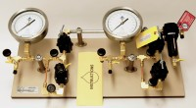 | Combination Manifold.  Code: 532-136  Product Group: Pressure plate extractors  This unit is designed for precise low pressure measurement for 15 bar extractor units, or for running 5 bar and 15 bar units simultaneously from a single pressure source. The unit is based on a combination of components from 532-110 and 532-128.

