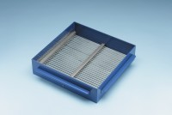 | Grid Sieve 16mm Slot Width for EN Aggregate Flakiness Test.  Code: 42-0318  Product Group: Grid Sieves  16mm

Standards
EN 933-3

Further Information
**NOT AVAILABLE FOR SALE IN THE USA**
Passing Size - 31.5 mm Retained Size - 25 mm

