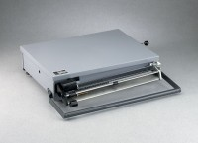 | Portable Bench Beam Scale - 131 lbs Capacity  Code: 88-1500  Product Group: Portable Bench Beam Scales

Specification
Capacity | 131 lbs.
Beams | 125 lb x 5 lb; 5 lb x 1 oz; 1 lb x 0.1 lb.
Tare | On fourth bar.
Platform | 17â w. x 12 â d. (432 x 305 mm).
Locking Device | Lever type.
Carrying Handle | Built-in.
Weights | Net 23 lbs. (10.4 kg).

