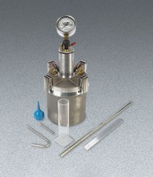 | Press-Ur-Meter Type A  Code: 34-3267  Product Group: Press-Ur-Meter  Includes straight edge, syringe, calibration vessel, tamping rod and carrying case.

Standards
ASTM C231, AASHTO T152

Specification
Capacity | 1/4 cu. Ft. (0.007 mÂ³)
Aggregate Size | 2" (50.8 mm) maximum
Pump | Built-in
Gauge | Direct-reading; 3-1/2" (89 mm) diam.
Clamps | Quick-operating
Overall Height | 20-1/2" (521 mm)
Weight | Net 35 lbs (16 kg)

Spares/Consumables
 | Concrete Air Indicator  Code: 38-3280/10

