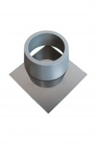 | ASTM Vicat Mould  Code: 38-2660  Product Group: Vicat Apparatus, Vicat Method, Automatic Vicat  Accessory: manufactured from non-absorbent plastic and supplied complete with a glass base plate.

Standards
ASTM C187, ASTM C191

Spares/Consumables
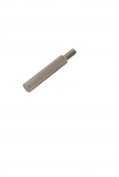 | Consistency Plunger  Code: 38-2010/10

