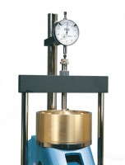 | Dial Gauge 10mm Travel X 0.002mm Divisions.  Code: 25-0440  Product Group: Measurement of Horizontal and Vertical Movement, Vertical settlement measurement, Direct/Residual Shear Apparatus  10 mm x 0.002 mm div.

