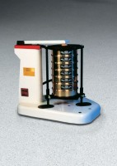 | Ro-Tap Sieve Shaker for 8" Diameter Sieves - 230V 60 Hz  Code: 80-0420/06  Product Group: Ro-Tap Sieve Shakers  230vAC, 60 Hz, 1ø.

