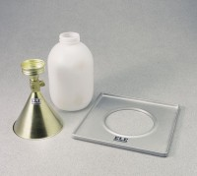 | 4" Field Density Plate  Code: 29-4294  Product Group: Field Density Plates  For use with EI29-4292 Sand Density Cone.

Standards
ASTM D1556, AASHTO T191

