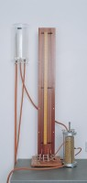 | Manometer Tubes & Stand.  Code: 25-0591  Product Group: Constant Head Apparatus  Comprising three glass tubes of constant bore, metre scale and connecting tubing for cell pressure take-off points, all mounted on a free-standing panel.Comprising three glass tubes of constant bore, metre scale and connecting tubing for cell pressure take-off points, all mounted on a free-standing panel.

Standards
BS 1377, EN 1997-2, ASTM D2434, AASHTO T215

