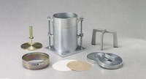 | CBR Mould  Code: 24-9229  Product Group: CBR Mould

Standards
ASTM D1883, AASHTO T193

Specification
Mould | 6â i.d. x 7â h. (152 .4 x 177.8 mm).
Collar | 2â h. (50.8 mm); fits both ends of mold.
Base Plate | Perforated; fits both ends of mold.
Construction | All steel; plated.
Weight | Net 20 lbs. (9 kg).

