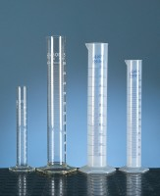 | Measuring Cylinder - Glass 500 ml  Code: 82-0460  Product Group: Measuring Cylinders, BS  Soda glass, spouted, BS EN 4788.

Further Information
**NOT AVAILABLE FOR SALE IN THE USA**

