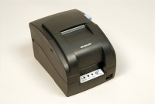 | Impact Printer Rs232 Serial Connection. Supplied Complete with 1 Paper Roll.  Code: 37-4859/02  Product Group: Printing of results, ADR TOUCH Digital Readout Unit Accessories  Supplied complete with serial RS232 communications cable and one paper roll.

Further Information
100 - 120 V AC, 60 Hz, 1 ph.

