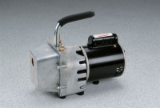 | High Vacuum Pump  Code: 88-3110/02  Product Group: Tri-Flex 2 Master Control Panel, High Vacuum Pump  115vAC, 50/60 Hz, 1ø.

Specification
Free Air Display | 85 liters per minute (3 cu. ft. per minute).
Ultimate Vacuum | 29.95 inches of mercury.
Motor/Pump | 1/3 hp; speed 1725 rpm.
Operating Temperature | 30Â°F to 170Â°F (0Â°C to 78Â°C).
Intake Port | 1/4â o.d. for 1/4â tubing.
Dimensions | 11 -1/4â h. x 15 -1/2â l. x 6-1/2â w. (29 x 39 x 16 cm).
Weight | Net 28 lbs. (12 .7 kg).

