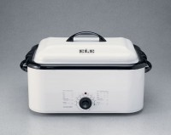 | Economy Water Bath  Code: 45-6475/02  Product Group: Economy Water Bath

Further Information
115vAC, 50/60 Hz, 1ø. 1,320 Watts.

Specification
Control | Setting dial.
Capacity | 8 standard Marshall specimens.
False Bottom | Grid-type.
Finish | Baked enamel.
Weight | Net 30 lbs. (13 .6 kg).

