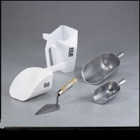 | Plastic Flat Bottom Scoop - 2 qt. Capacity  Code: 88-7312  Product Group: Plastic Flat Bottom Scoops  2 qt. (1.89 liters) capacity.

Specification
Bowl Dimensions | 8-1/4â x 6â x 5â (210 x 152 x 127 mm).

